NAME: JEEVITHA.S-192324020
DATA BASE MANAGEMENT SYSTEM FOR WEB APPLICATION(CSA0555)
Automated ticket generator for calculating profit or loss by date
(i) Create a conceptual model (ii) implement database using SQL (iii) use PL/SQL

(i)Physical Model
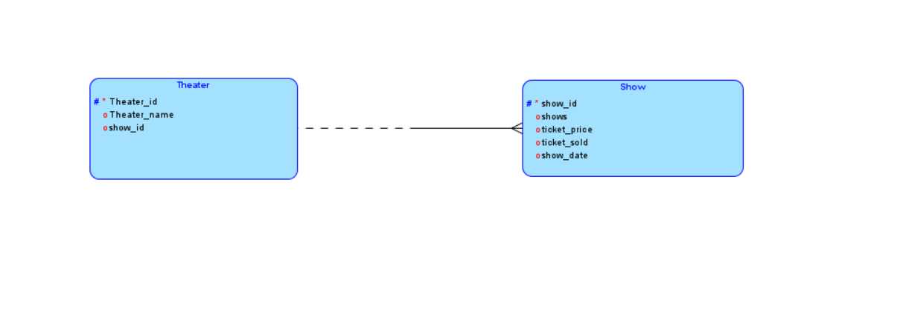
Relational Model
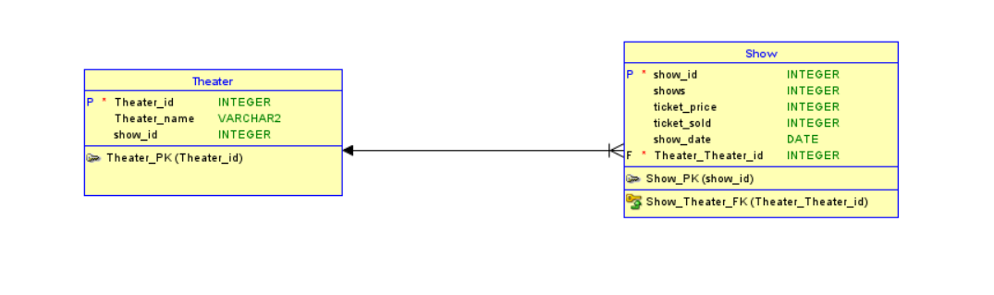
(ii)
CREATE TABLE Theater(theater_id NUMBER PRIMARY KEY,theater_name VARCHAR2(20),show_id NUMBER);
INSERT INTO Theater VALUES(1,'Theater 1',101);
INSERT INTO Theater VALUES(2,'Theater 2',102);
INSERT INTO Theater VALUES(3,'Theater 3',103);
INSERT INTO Theater VALUES(4,'Theater 4',104);
SELECT * FROM Theater;
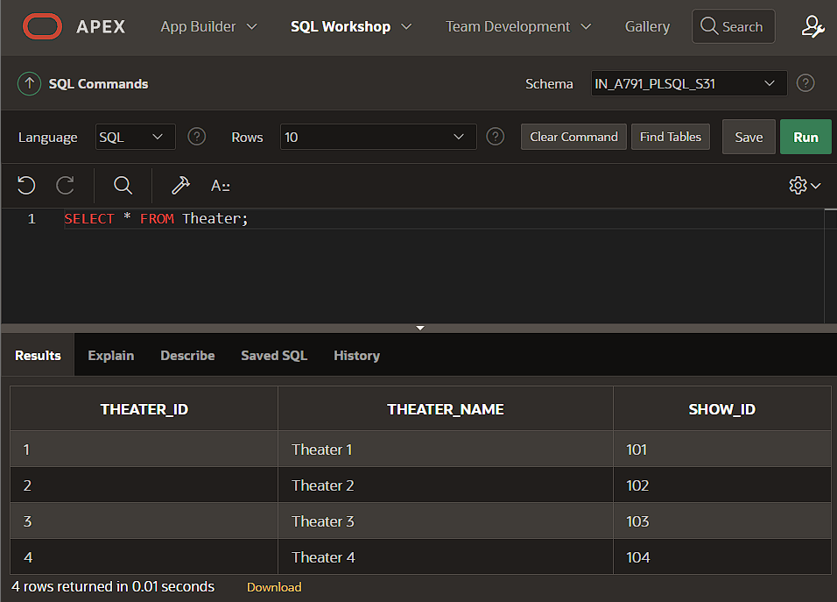
CREATE TABLE show(show_id NUMBER PRIMARY KEY,shows NUMBER,ticket_price NUMBER,ticket_sold NUMBER,show_date DATE,theater_id NUMBER,FOREIGN KEY (theater_id) REFERENCES Theater(theater_id));
INSERT INTO show VALUES(101,3,120,300,TO_DATE('2024-08-15', 'YYYY-MM-DD'),1);
INSERT INTO show VALUES(102,3,120,270,TO_DATE('2024-08-17', 'YYYY-MM-DD'),2);
INSERT INTO show VALUES(103,3,120,160,TO_DATE('2024-08-14', 'YYYY-MM-DD'),3);
INSERT INTO show VALUES(104,3,120,255,TO_DATE('2024-08-18', 'YYYY-MM-DD'),4);
SELECT * FROM show ORDER BY SHOW_ID;
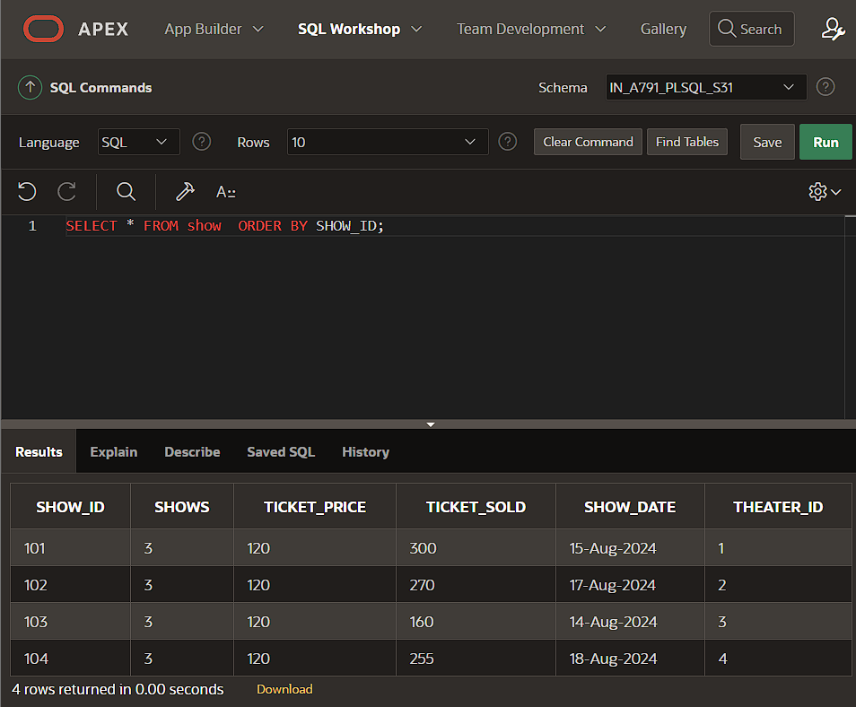

(iii)
CREATE OR REPLACE PROCEDURE Calculate_Profit_Loss IS
income NUMBER;
expenses NUMBER := 90000;
r NUMBER;
profit_loss VARCHAR2(20);
CURSOR c1 IS
SELECT s.shows,s.ticket_sold,s.ticket_price,s.show_date,t.theater_name,t.show_id FROM Show s JOIN Theater t ON s.theater_id = t.theater_id;
BEGIN
FOR s IN c1 LOOP
income := s.ticket_sold * s.ticket_price * s.shows;
r:= income - expenses;
IF r>0 THEN
profit_loss := 'Profit';
ELSE
profit_loss := 'Loss';
END IF;
DBMS_OUTPUT.PUT_LINE('Show Date: '||TO_CHAR(s.show_date, 'YYYY-MM-DD')||' | Theater: '||s.theater_name||' | Net Profit/Loss: '||profit_loss);
END LOOP;
END;
/

BEGIN
Calculate_Profit_Loss;
END;
/
